**Реляційна модель представлення даних**

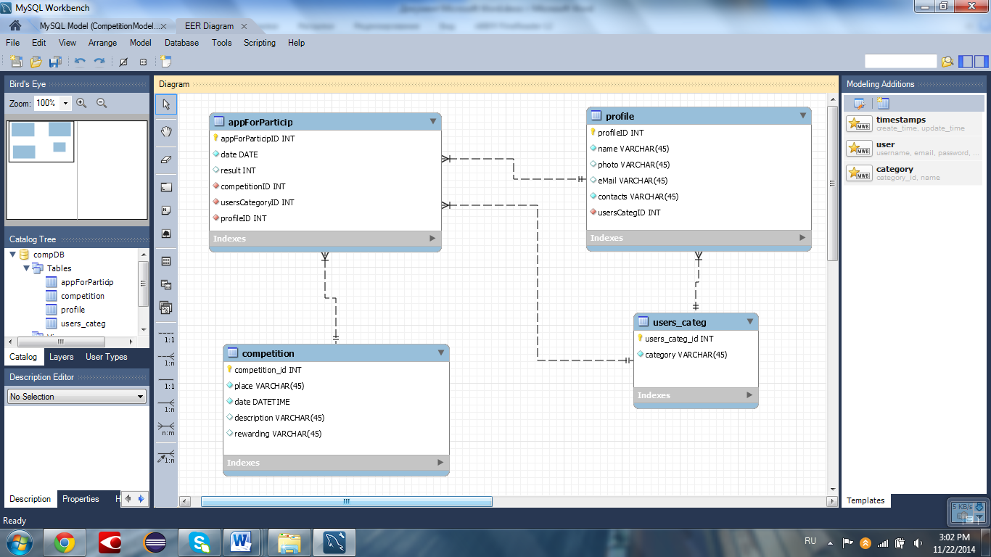

**Створення таблиць**

SET @OLD_UNIQUE_CHECKS=@@UNIQUE_CHECKS, UNIQUE_CHECKS=0;

SET @OLD_FOREIGN_KEY_CHECKS=@@FOREIGN_KEY_CHECKS, FOREIGN_KEY_CHECKS=0;

SET @OLD_SQL_MODE=@@SQL_MODE, SQL_MODE='TRADITIONAL,ALLOW_INVALID_DATES';

-- -----------------------------------------------------

-- Schema compDB

-- -----------------------------------------------------

DROP SCHEMA IF EXISTS `compDB` ;

-- -----------------------------------------------------

-- Schema compDB

-- -----------------------------------------------------

CREATE SCHEMA IF NOT EXISTS `compDB` DEFAULT CHARACTER SET utf8 ;

SHOW WARNINGS;

USE `compDB` ;

-- -----------------------------------------------------

-- Table `users_categ`

-- -----------------------------------------------------

DROP TABLE IF EXISTS `users_categ` ;

SHOW WARNINGS;

CREATE TABLE IF NOT EXISTS `users_categ` (

`users_categ_id` INT NOT NULL,

`category` VARCHAR(45) NOT NULL,

PRIMARY KEY (`users_categ_id`))

ENGINE = InnoDB;

SHOW WARNINGS;

-- -----------------------------------------------------

-- Table `profile`

-- -----------------------------------------------------

DROP TABLE IF EXISTS `profile` ;

SHOW WARNINGS;

CREATE TABLE IF NOT EXISTS `profile` (

`profileID` INT NOT NULL,

`name` VARCHAR(45) NOT NULL,

`photo` VARCHAR(45) NULL,

`eMail` VARCHAR(45) NULL,

`contacts` VARCHAR(45) NOT NULL,

`usersCategID` INT NOT NULL,

PRIMARY KEY (`profileID`),

CONSTRAINT `fk_Profile_Users category`

FOREIGN KEY (`usersCategID`)

REFERENCES `users_categ` (`users_categ_id`)

ON DELETE NO ACTION

ON UPDATE NO ACTION)

ENGINE = InnoDB;

SHOW WARNINGS;

CREATE INDEX `fk_Profile_Users category_idx` ON `profile` (`usersCategID` ASC);

SHOW WARNINGS;

-- -----------------------------------------------------

-- Table `competition`

-- -----------------------------------------------------

DROP TABLE IF EXISTS `competition` ;

SHOW WARNINGS;

CREATE TABLE IF NOT EXISTS `competition` (

`competition_id` INT NOT NULL,

`place` VARCHAR(45) NOT NULL,

`date` DATETIME NOT NULL,

`description` VARCHAR(45) NULL,

`rewarding` VARCHAR(45) NULL,

PRIMARY KEY (`competition_id`))

ENGINE = InnoDB;

SHOW WARNINGS;

-- -----------------------------------------------------

-- Table `appForParticip`

-- -----------------------------------------------------

DROP TABLE IF EXISTS `appForParticip` ;

SHOW WARNINGS;

CREATE TABLE IF NOT EXISTS `appForParticip` (

`appForParticipID` INT NOT NULL,

`date` DATE NOT NULL,

`result` INT NULL,

`competitionID` INT NOT NULL,

`usersCategoryID` INT NOT NULL,

`profileID` INT NOT NULL,

PRIMARY KEY (`appForParticipID`),

CONSTRAINT `fk_Application for participation_Competition1`

FOREIGN KEY (`competitionID`)

REFERENCES `competition` (`competition_id`)

ON DELETE NO ACTION

ON UPDATE NO ACTION,

CONSTRAINT `fk_Application for participation_Users category1`

FOREIGN KEY (`usersCategoryID`)

REFERENCES `users_categ` (`users_categ_id`)

ON DELETE NO ACTION

ON UPDATE NO ACTION,

CONSTRAINT `fk_Application for participation_Profile1`

FOREIGN KEY (`profileID`)

REFERENCES `profile` (`profileID`)

ON DELETE NO ACTION

ON UPDATE NO ACTION)

ENGINE = InnoDB;

SHOW WARNINGS;

CREATE INDEX `fk_Application for participation_Competition1_idx` ON `appForParticip` (`competitionID` ASC);

SHOW WARNINGS;

CREATE INDEX `fk_Application for participation_Users category1_idx` ON `appForParticip` (`usersCategoryID` ASC);

SHOW WARNINGS;

CREATE INDEX `fk_Application for participation_Profile1_idx` ON `appForParticip` (`profileID` ASC);

SHOW WARNINGS;

**Заповнення таблиць даними**

SET @OLD_UNIQUE_CHECKS=@@UNIQUE_CHECKS, UNIQUE_CHECKS=0;

SET @OLD_FOREIGN_KEY_CHECKS=@@FOREIGN_KEY_CHECKS, FOREIGN_KEY_CHECKS=0;

SET @OLD_SQL_MODE=@@SQL_MODE, SQL_MODE='TRADITIONAL,ALLOW_INVALID_DATES';

-- -----------------------------------------------------

-- Data for table `users_categ`

-- -----------------------------------------------------

START TRANSACTION;

USE `compDB`;

INSERT INTO `users_categ` (`users_categ_id`, `category`) VALUES (1, 'participant');

INSERT INTO `users_categ` (`users_categ_id`, `category`) VALUES (2, 'judge');

INSERT INTO `users_categ` (`users_categ_id`, `category`) VALUES (3, 'guest');

INSERT INTO `users_categ` (`users_categ_id`, `category`) VALUES (4, 'organizer');

COMMIT;

-- -----------------------------------------------------

-- Data for table `profile`

-- -----------------------------------------------------

START TRANSACTION;

USE `compDB`;

INSERT INTO `profile` (`profileID`, `name`, `photo`, `eMail`, `contacts`, `usersCategID`) VALUES (1, 'Pavluchkov Vlad', NULL, NULL, '0981223425', 1);

INSERT INTO `profile` (`profileID`, `name`, `photo`, `eMail`, `contacts`, `usersCategID`) VALUES (2, 'Zmeul Evgeniy', NULL, NULL, '0671234569', 2);

INSERT INTO `profile` (`profileID`, `name`, `photo`, `eMail`, `contacts`, `usersCategID`) VALUES (3, 'Morozov Maks', NULL, NULL, '0671234565', 3);

INSERT INTO `profile` (`profileID`, `name`, `photo`, `eMail`, `contacts`, `usersCategID`) VALUES (4, 'Popenko Ruslan', NULL, NULL, '0984582499', 4);

COMMIT;

-- -----------------------------------------------------

-- Data for table `competition`

-- -----------------------------------------------------

START TRANSACTION;

USE `compDB`;

INSERT INTO `competition` (`competition_id`, `place`, `date`, `description`, `rewarding`) VALUES (1, 'Stadium Start', '2014-11-15 19:00:00', NULL, NULL);

INSERT INTO `competition` (`competition_id`, `place`, `date`, `description`, `rewarding`) VALUES (2, 'Metro Gidropark bus station', '2014-11-19 19:00:00', NULL, NULL);

COMMIT;

-- -----------------------------------------------------

-- Data for table `appForParticip`

-- -----------------------------------------------------

START TRANSACTION;

USE `compDB`;

INSERT INTO `appForParticip` (`appForParticipID`, `date`, `result`, `competitionID`, `usersCategoryID`, `profileID`) VALUES (1, '2014-11-15', NULL, 1, 1, 1);

INSERT INTO `appForParticip` (`appForParticipID`, `date`, `result`, `competitionID`, `usersCategoryID`, `profileID`) VALUES (2, '2014-11-19', NULL, 2, 1, 1);

INSERT INTO `appForParticip` (`appForParticipID`, `date`, `result`, `competitionID`, `usersCategoryID`, `profileID`) VALUES (3, '2014-11-15', NULL, 1, 2, 2);

INSERT INTO `appForParticip` (`appForParticipID`, `date`, `result`, `competitionID`, `usersCategoryID`, `profileID`) VALUES (4, '2014-11-19', NULL, 2, 2, 2);

INSERT INTO `appForParticip` (`appForParticipID`, `date`, `result`, `competitionID`, `usersCategoryID`, `profileID`) VALUES (5, '2014-11-15', NULL, 1, 3, 3);

INSERT INTO `appForParticip` (`appForParticipID`, `date`, `result`, `competitionID`, `usersCategoryID`, `profileID`) VALUES (6, '2014-11-19', NULL, 2, 3, 3);

INSERT INTO `appForParticip` (`appForParticipID`, `date`, `result`, `competitionID`, `usersCategoryID`, `profileID`) VALUES (7, '2014-11-15', NULL, 1, 4, 4);

INSERT INTO `appForParticip` (`appForParticipID`, `date`, `result`, `competitionID`, `usersCategoryID`, `profileID`) VALUES (8, '2014-11-19', NULL, 2, 4, 4);

COMMIT;

SET SQL_MODE=@OLD_SQL_MODE;

SET FOREIGN_KEY_CHECKS=@OLD_FOREIGN_KEY_CHECKS;

SET UNIQUE_CHECKS=@OLD_UNIQUE_CHECKS;

**Генерація таблиць**

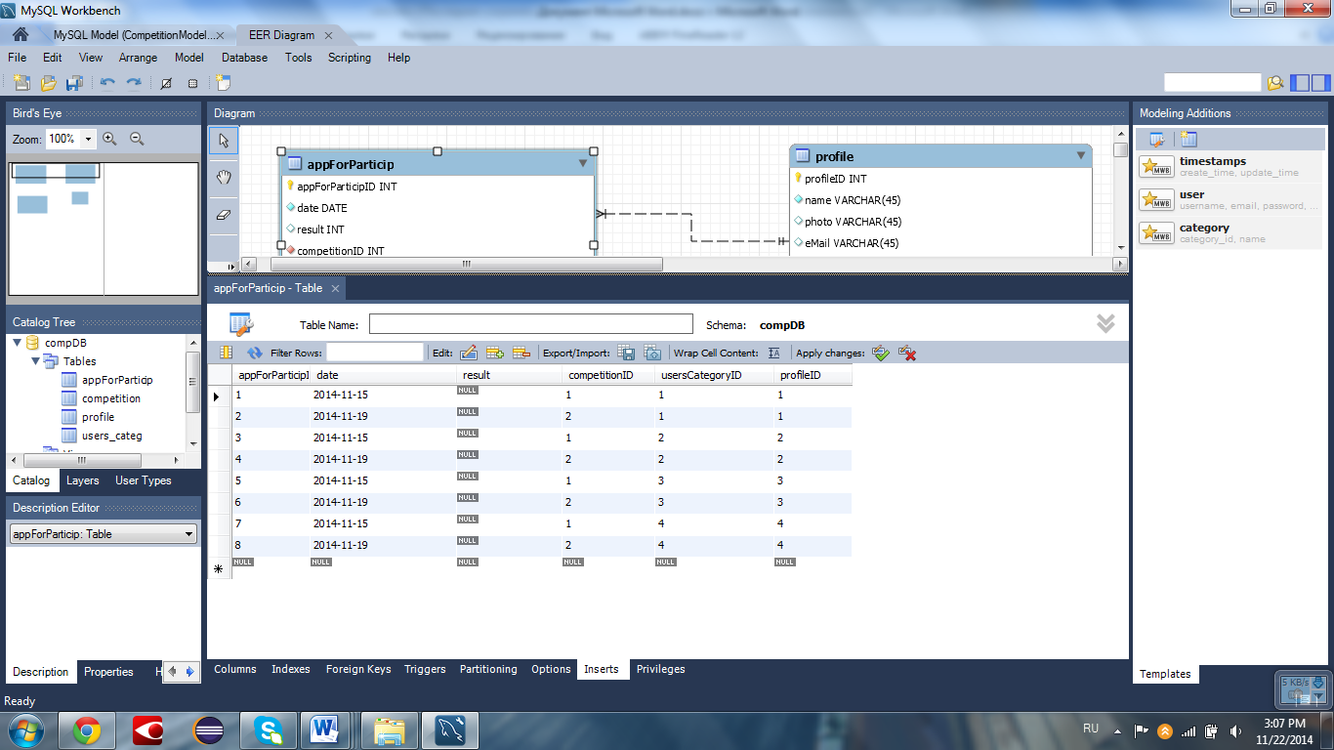

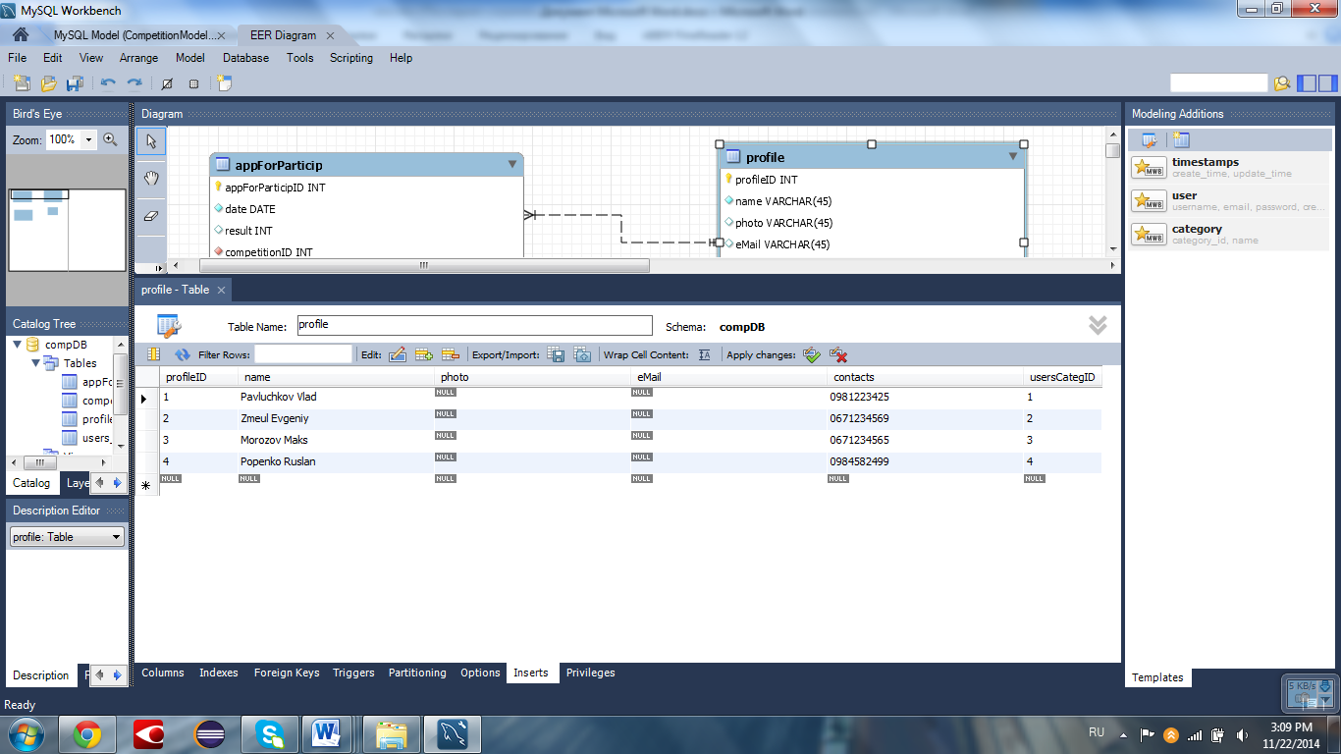

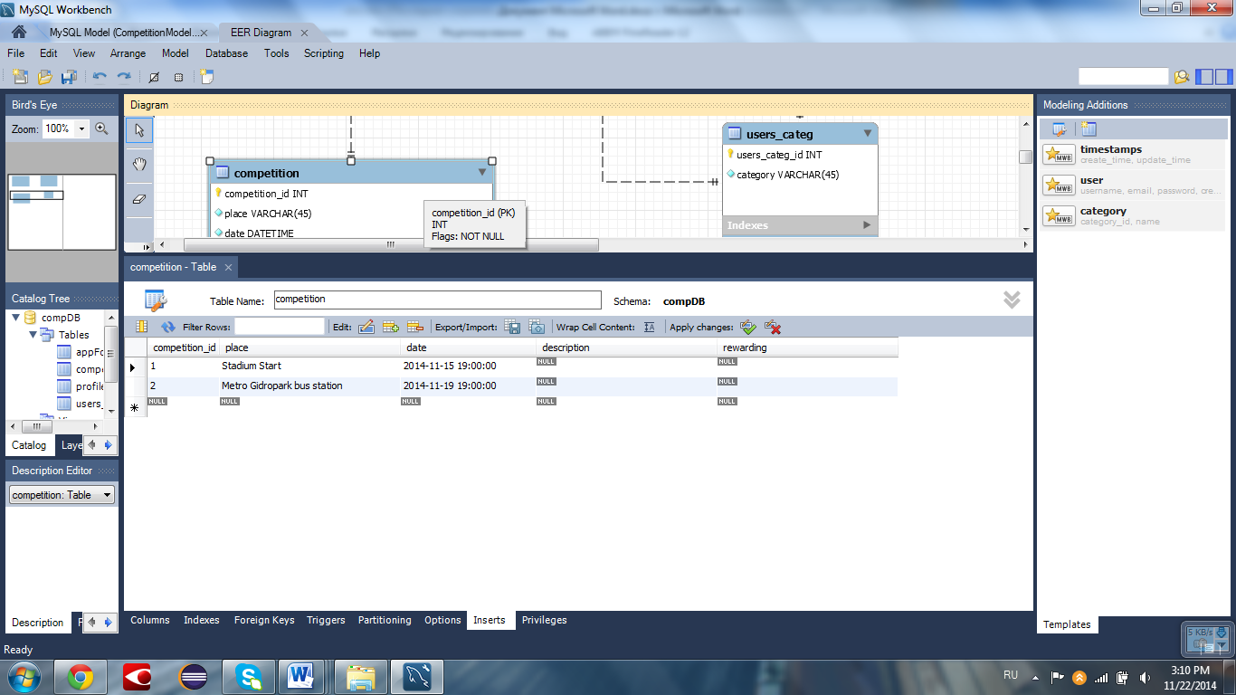

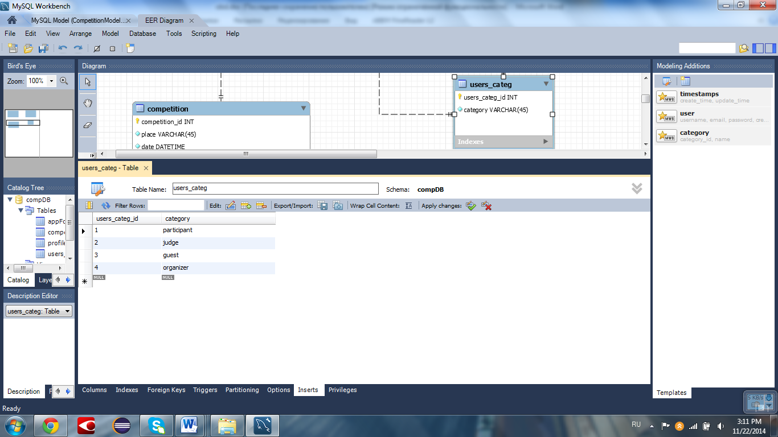

**Код класу Test**

**package** obd;

**import** java.sql.Connection;

**import** java.util.Date;

**import** java.sql.DriverManager;

**import** java.sql.SQLException;

**import** java.sql.Statement;

**import** java.sql.ResultSet;

**import** java.sql.Time;

/**

* **@author** Group 4

*

* **@version**

*/

**public** **class** **Test** {

**public** **static** **void** **main**(**String**[] args) {

Connection **connection** = **null**;

Statement **statement** = **null**;

Statement **statement2** = **null**;

Statement **statement3** = **null**;

**String** **query** = "select*from competition";

**try** {

**Class**.*forName*("com.mysql.jdbc.Driver");

connection = **DriverManager**.*getConnection*(

"jdbc:mysql://localhost/compDB", "root", "1111");

statement = connection.createStatement();

ResultSet **rs** = statement.executeQuery(query);

*printCompetitions*(rs);

query = "insert into `compDB`.`profile`(`profileID`, `name`, `photo`, `eMail`, `contacts`, `usersCategID`) VALUES ('5','Korchak Myhailo','','','05055555555','3')";

statement2 = connection.createStatement();

statement2.executeUpdate(query);

query = "select*from profile";

rs = statement2.executeQuery(query);

*printProfile*(rs);

statement3 = connection.createStatement();

query = "delete from `compDB`.`profile`" + "where `profileID`=5";

statement3.executeUpdate(query);

connection.close();

} **catch** (**Exception** **e**) {

e.printStackTrace();

}

}

**private** **static** **void** **printProfile**(ResultSet rs) **throws** **SQLException** {

**int** **ProfileID**, **UsersCategID**;

**String** **name**, **photo**, **eMail**, **contacts**;

**while** (rs.next()) {

ProfileID = rs.getInt(1);

name = rs.getString(2);

photo = rs.getString(3);

eMail = rs.getString(4);

contacts = rs.getString(5);

UsersCategID = rs.getInt(6);

**System**.***out***.println("--------------------------");

**System**.***out***.println("ProfileID= " + ProfileID);

**System**.***out***.println("name: " + name);

**System**.***out***.println("photo: " + photo);

**System**.***out***.println("e-mail: " + eMail);

**System**.***out***.println("contacts: " + contacts);

**System**.***out***.println("UsersCategID= " + UsersCategID);

**System**.***out***.println("-----------------------------");

}

}

**private** **static** **void** **printCompetitions**(ResultSet rs) **throws** **SQLException** {

**int** **competitionID**;

**String** **place**, **description**, **rewarding**;

**Date** **date**;

**Time** **time**;

**while** (rs.next()) {

competitionID = rs.getInt(1);

place = rs.getString(2);

date = rs.getDate(3);

time = rs.getTime(3);

description = "";

rewarding = "";

**System**.***out***.println("-----------------------------");

**System**.***out***.println("CompetitionID= " + competitionID);

**System**.***out***.println("Place: " + place);

**System**.***out***.println("Date: " + date + " " + time);

**System**.***out***.println("Description: " + description);

**System**.***out***.println("Rewarding: " + rewarding);

**System**.***out***.println("------------------------------");

}

}

}

**Результати роботи програми**

CompetitionID= 1

Place: Stadium Start

Date: 2014-11-15 19:00:00

Description:

Rewarding:

------------------------------

-----------------------------

CompetitionID= 2

Place: Metro Gidropark bus station

Date: 2014-11-19 19:00:00

Description:

Rewarding:

------------------------------

--------------------------

ProfileID= 1

name: Pavluchkov Vlad

photo: null

e-mail: null

contacts: 0981223425

UsersCategID= 1

-----------------------------

--------------------------

ProfileID= 2

name: Zmeul Evgeniy

photo: null

e-mail: null

contacts: 0671234569

UsersCategID= 2

-----------------------------

--------------------------

ProfileID= 3

name: Morozov Maks

photo: null

e-mail: null

contacts: 0671234565

UsersCategID= 3

-----------------------------

--------------------------

ProfileID= 4

name: Popenko Ruslan

photo: null

e-mail: null

contacts: 0984582499

UsersCategID= 4

--------------------------

ProfileID= 5

name: Korchak Myhailo

photo:

e-mail:

contacts: 05055555555

UsersCategID= 3